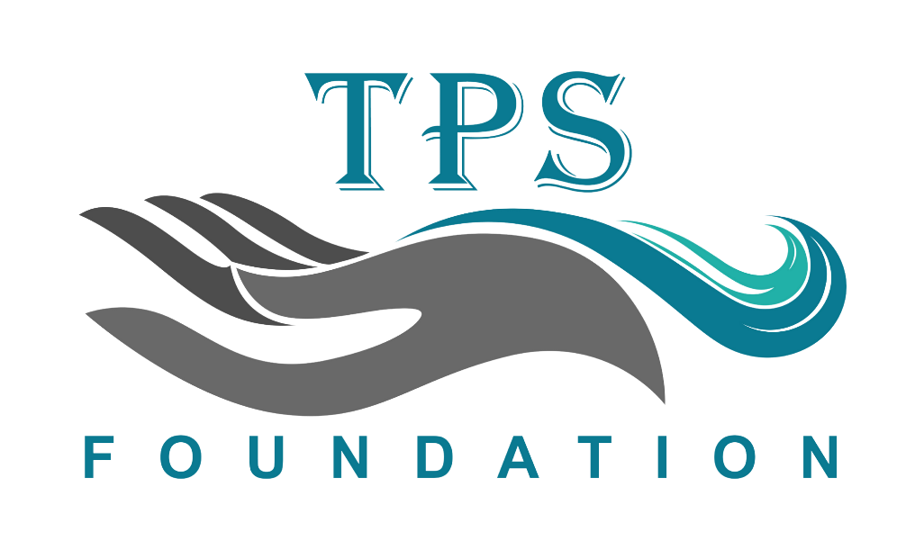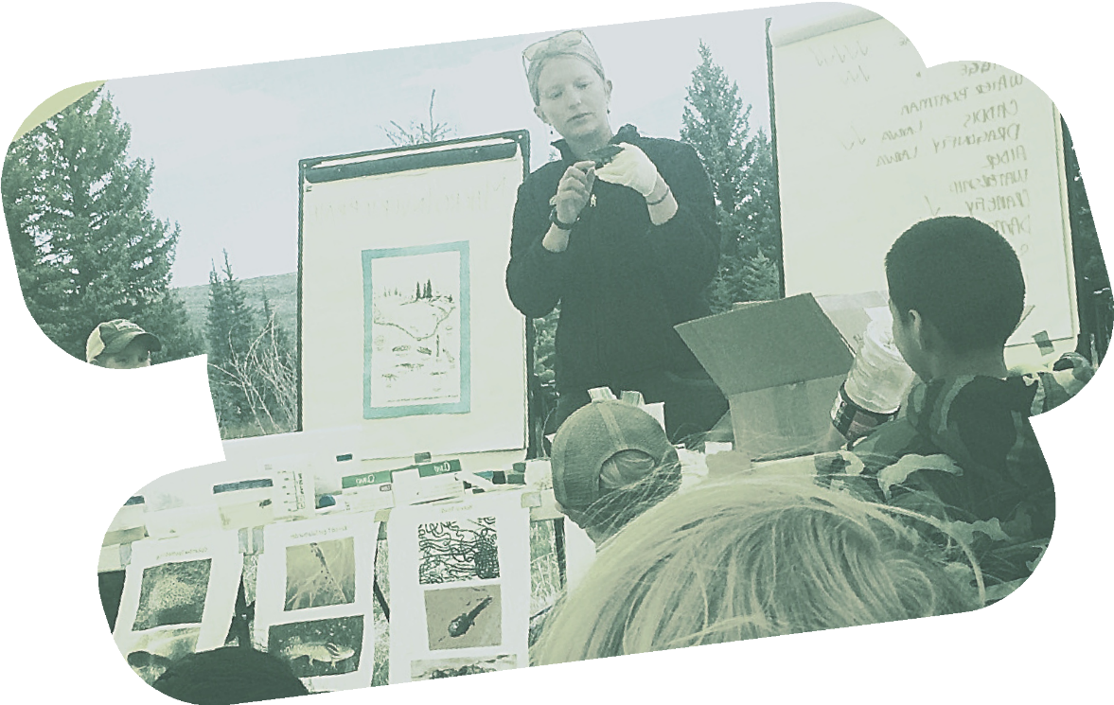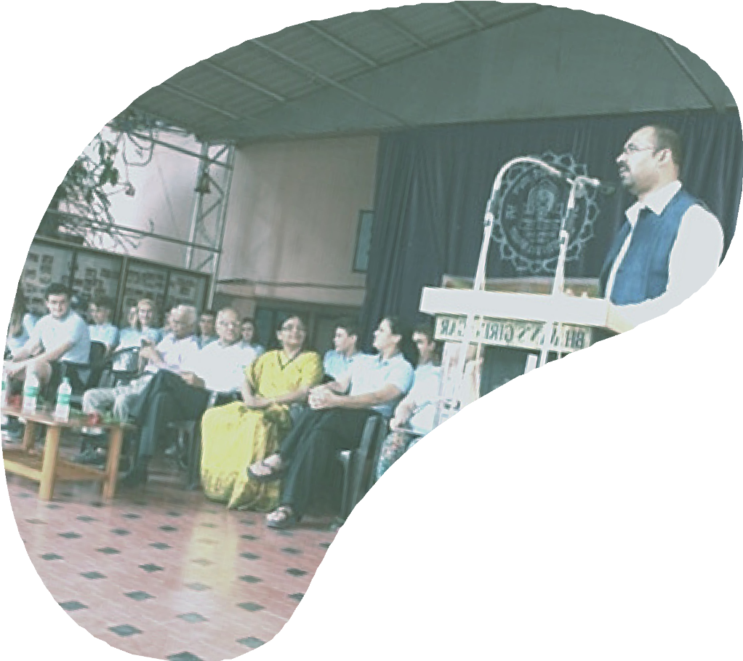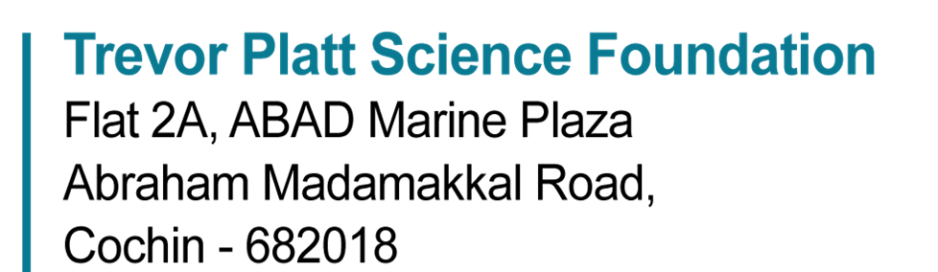

Call for Outreach Projects

**The Trevor Platt Science Foundation announces small-duration outreach projects. The call is for proposals on outreach activities in your country aimed at schools, colleges or the general public. The maximum duration of the activity is 6 months. The activity should help to create awareness in the target community on marine or freshwater ecosystems, resources, their conservation and their sustainable management. The maximum fund available per project is 500 British Pounds (GBP), which can be used for the project-related travel, educational materials, flyers, and other related expenses. Institutional charges will not be covered.**

**Funding will be available for two or three projects to be completed in 2025.**

**The call is open to all who have been associated with TPSF in one way or the other. Non-members should include a TPSF member as co-investigator for consideration of their proposals.**

**Please apply using the template available on the website** [**https://www.trevorfoundation.org/outreach**](https://www.trevorfoundation.org/outreach)**. Submit to** [**contact@trevorfoundation.org**](mailto:contact@trevorfoundation.org) **by 31st May 2025. Results will be announced on 30th June 2025.**

**Terms and Conditions:**

1. **The call is open to all associated with the Foundation. Non-members should include a TPSF member as co-investigator.**
2. **Preference will be given to applications from developing countries, but applications from developed countries will also be considered.**
3. **A selection committee will evaluate the applications, according to quality of the proposal and the applicant, with consideration for geographic representation.**
4. **The recipients of the grants must agree to provide a written report on completion of the project, and no later than December, 2025.**

**Note: The start of the successful projects will be from the date of receipt of the funds or 1st July 2025, whichever is earlier.**

Enquiry: [contact@trevorfoundation.org](mailto:contact@trevorfoundation.org)

[http://www.trevorfoundation.org](http://www.trevorfoundation.org/)

**"Blackrock Field Camp_Leah" by Intermountain Region US Forest Service is marked with CC PDM 1.0**